**ATAR HUMAN BIOLOGY UNIT 3**

**Task 3 – Investigating Homeostasis**

**Weighting – 2%**

**Score - /22 ___ %**

**Name - _______________________________________**

**The following investigation will have two parts:**

Part One – carry out an investigation into homeostasis. (4 marks)

Part Two – Analysis of data from experiments on homeostasis (18 marks)

The respiratory cycle of inspiration and expiration is controlled by the medulla oblongata in conjunction with the peripheral nervous system and the body’s chemoreceptors. Information from the chemoreceptors in the carotid and aortic bodies and the medulla oblongata inform the brain of the levels of carbon dioxide, oxygen and hydrogen ions (pH). An increase in carbon dioxide will stimulate an increase in breathing rate, whilst a decrease inhibits it. An increase in carbon dioxide levels also causes vasodilation of blood vessels.

At rest, the average male produces 200ml of CO2 each minute, but may increase to 2000ml with exercise or heavy work. Hyperventilation lowers CO2 levels as more gas exchange is taking place to remove CO2 from the body, but holding ones breath increases levels.

In normal breathing about 1/10th of the total lung capacity is used. The volume of air breathed in and out without conscious effort (normal breathing) is called “Tidal Volume”, while “Vital Capacity” is the total amount of air that can be inspired and expired. The amount of air that could be drawn in is called “Inspiratory Reserve volume” and the amount of air that can be exhaled is called “Expiratory Reserve volume”. The air that remains in the lungs after maximum exhalation is called “Residual Volume”.

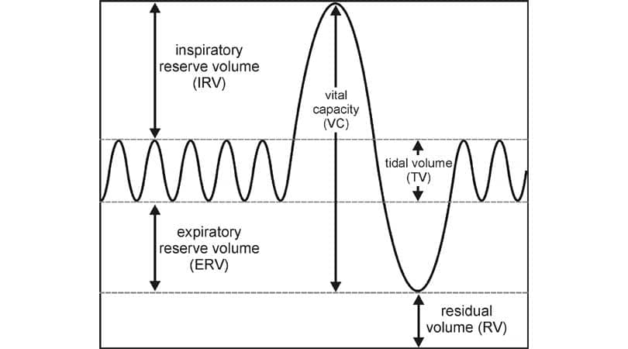

In the following practical you are going to investigate whether changing gas concentrations inside your body to beyond the body’s tolerance levels will initiate a response by the homeostatic mechanisms controlling blood gas levels.

You are going to compare the tidal volumes and breathing rates recorded whilst the body under takes various physiological challenges. You will then correlate your findings with real life situations.

Write a hypothesis regarding what change, you infer, would occur in the body that would instigate an increase in tidal volume. (1 mark)

Eg If the carbon dioxide levels in the blood increase then the tidal volume will also increase.

**Method**

**Part 1 : Tidal volume response to Breath holding.**

1. Connect the spirometer to the Vernier interface and connect interface to the computer, switch Interface on first. Then open the programme “Logger Pro” on the computer and the graph showing tidal volume should appear. Change the settings so that data will be collected for 120 secs. *Go to “Experiment”, “Data Collection” – change duration to 120seconds and sample rate to 5 per second, then press done.*
2. Connect disposable mouth piece to the spirometer as shown below in figure 2.

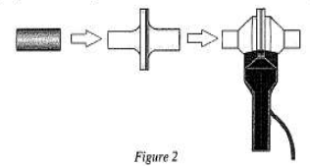

1. Hold the spirometer in both hand whilst sitting so it is straight up and down. Place the nose clips on your nose. Ensure mouth is completely sealed around the mouth piece.
2. Click  to begin collecting data. Take 4 normal breaths (inhalation and exhalation). Then take a deep breath and hold your breath for 40 seconds (approx.). Stop holding your breath and continue to breathe until 120 secs is completed.
3. 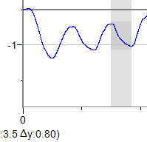Click the Next Page button – *“Page”, then click next page.* This will show your lung volume measurements. If the baseline on your volume graph is not on the line/straight, use the “Baseline_Adjustment tool” to bring closer to the line.
4. Select a peak and then drag down to the valley on one breath prior to holding; ensure peak to valley is darkened. Record the y value, this is your tidal volume in litres.

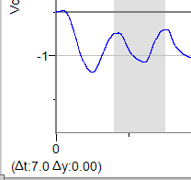

1. Select two adjacent peaks recorded whilst breathing normally. Drag the cursor from one peak to the next. Record the t value shown. This will give you the time for one breath. From this calculate the respiration rate : (60 / t x Number of breaths = breaths /min)
2. Calculate the Minute Ventilation value for this period by :

Tidal Volume x respiration rate = Minute Ventilation.

1. Record the results in a table. Then save the data in Get Work under Human Biology in your name.
2. Carry out the same calculations in steps 5 -8 for the recordings directly after the period of breath holding. Each time saving the data.

**Part II – Tidal Volume response to Hyperventilation**

1. Repeat Steps 4 – 10. This time breathe normally for 4 breaths, then begin to breathe deeply and rapidly for 40seconds (approx.), then continue with normal breathing until the 120 seconds has finished.
2. Carry out the same calculations for the breaths prior to the activity and the breaths after the period of rapid breathing.

**Part III – Tidal Volume response to Exercise**

1. Repeat Steps 4 – 10 again. This time breathe normally for 4 breaths, then begin to running on the spot for 40seconds (approx.), then continue with normal breathing until the 120 seconds has finished.
2. Carry out the same calculations for the breaths prior to the activity and the breaths after the period of exercise.

Table should have correct headings (1), neatly drawn(1), using correct scientific terminology or units (1) (3 marks)

1. Describe the changes in respiratory rates, tidal volumes and minute ventilations that occurred after each of the physiological challenges. (3 marks)

|  |  |  |  |
| --- | --- | --- | --- |
|  | **Respiration rate** | **Tidal volume** | **Minute ventilation** |
| **Hold Breath** | Higher | Higher | Higher |
| **Hyperventilate** | Decrease/same as before | Decrease (slightly) | Decrease (slightly) |
| **Exercise** | increase | Increase | Increase |

1. Explain, using your knowledge of the homeostatic control of gas levels in the body, why the changes in respiration rates and tidal volumes occurred in each challenge in terms of CO2 levels and their effects on the respiratory system. *(adjust according to results)* (6 marks)

|  |  |  |
| --- | --- | --- |
| No | Explanation | mark |
| 1 | Hold breath – the carbon dioxide levels build up in the blood stream/body  will trigger increase contractions of diaphragm/ intercostal muscles  will cause increase in rate of breathing/ muscles will increase tidal volume | Max 3 |
| 2 | Hyperventilation –reduce the levels of carbon dioxide lower than normal/reduce carbon dioxide and oxygen (shallow breathing)  No stimulus as levels of carbon dioxide below trigger point/increase stimulated as carbon dioxide down and also oxygen (shallow breathing)  Respiration / vital capacity remain the same as no trigger to cause a change/decrease slightly as carbon dioxide levels low/increase in breathing rate/vital capacity to remove carbon dioxide/increase oxygen | Max 3 |
| 3 | Exercise– the carbon dioxide levels build up in the blood stream from respiration  will trigger to increase contractions of diaphragm/ intercostal muscles  will cause increase in rate of breathing /will increase tidal volume  or increase sympathetic stimulation to dilate bronchi | Max 3 |
|  | Total of 3 marks from 1 & 3, max 3 marks from 2 | Total /6 |

1. Does the data you collected support your hypothesis? (2 marks)

Statement saying if supported or not (1)

Some data linked to give evidence as to why supported or not (1)

1. How might breathing into a paper bag help someone who is extremely anxious and hyperventilating? (3 marks)

|  |  |
| --- | --- |
| Explanation | Marks |
| Breathing in and out the same air increases the amount of carbon dioxide in the air | 1 |
| This causes carbon dioxide to diffuse into the blood/less carbon dioxide can diffuse out of the blood into the lungs/more carbon dioxide in the blood | 1 |
| High carbon dioxide conc in the blood triggers blood vessels to dilate reducing pressure/relieving tension  Or causes bronchi to dilate through sympathetic stimulation increasing air flow into the lungs reducing ability to hyperventilate/breathing deepens | 1 |
|  | Total /3 |

1. Some patients with severe emphysema have constant high levels of CO2 because of inadequate ventilation. The central nervous system breathing centre in these patients becomes insensitive to CO2 and more dependent on the levels of O2, which is low. These patients are said to have “oxygen-dependent respiratory drive”. Discuss what might happen if you give such a person high levels of supplemental O2? (4 marks)

|  |  |
| --- | --- |
| Explanation | Marks |
| Body relies on oxygen to trigger breathing so must be very low to do so | 1 |
| If oxygen high, more will diffuse into the blood /larger supply than normal | 1 |
| Will take longer for the levels to drop enough to trigger increase in breathing | 1 |
| Whilst oxygen levels dropping to trigger point carbon dioxide will have built up to a dangerously high level making blood acidic/increasing hydrogen ions | 1 |
| High acidity will cause enzymes to stop functioning and person in real danger | 1 |
|  | Total /4 |